Small Cubicuboctahedron

Definition
# Source: AI Source: Provided by: [Data Path: Persons Table -> ID Column: 1, Name_En Column: Motasem Essam] -> From: [ChatGPT] on [7/25/2026]
The Small Cubicuboctahedron is a non-convex uniform star polyhedron composed of 20 regular polygonal faces: 8 equilateral triangles, 6 squares, and 6 regular octagons.
It is characterized by intersecting faces, a crossed quadrilateral vertex figure, and full octahedral symmetry.
It is also known as Uniform Polyhedron U₁₃, and its principal classification references include Coxeter index 38 and Wenninger index 69.
Its Wythoff symbol is:
$$\boxed{\frac{3}{2} 4∣4}$$
Its dual polyhedron is the Small Hexacronic Icositetrahedron.

Geometric Representation
# Source: AI Source: Provided by: [Data Path: Persons Table -> ID Column: 1, Name_En Column: Motasem Essam] -> From: [ChatGPT] on [7/25/2026]
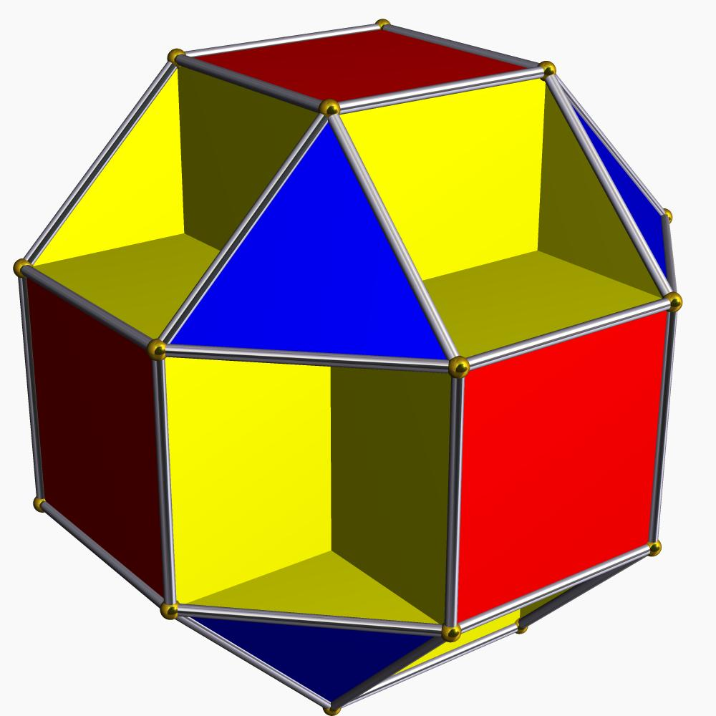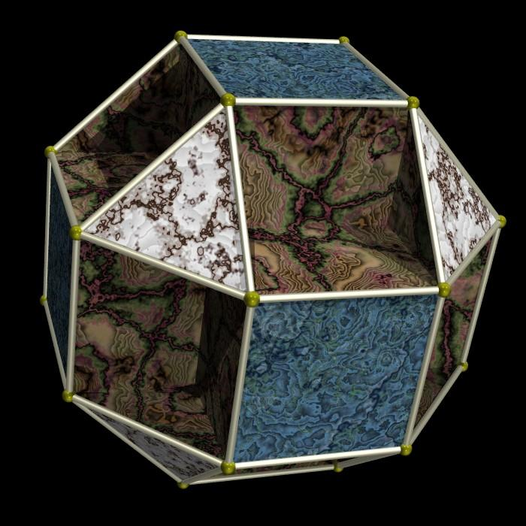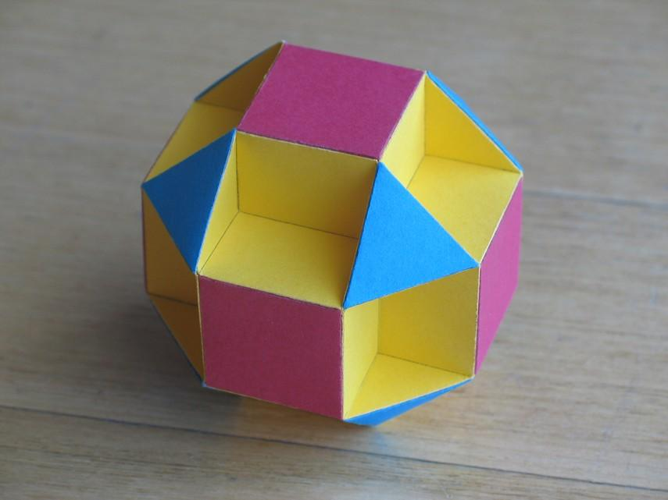

Geometric Structure
# Source: AI Source: Provided by: [Data Path: Persons Table -> ID Column: 1, Name_En Column: Motasem Essam] -> From: [ChatGPT] on [7/25/2026]
The Small Cubicuboctahedron consists of three types of regular polygonal faces:
- Triangular faces: 8 equilateral triangles.
- Square faces: 6 regular squares.
- Octagonal faces: 6 regular octagons.
Its structure has the following characteristics:
- All edges have equal lengths.
- All vertices are geometrically equivalent under its symmetry group.
- The faces intersect one another in three-dimensional space.
- The intersections create additional apparent lines, sometimes called false edges.
- False edges are not actual edges of the polyhedron.
- The polyhedron is a faceting of the rhombicuboctahedron.
The octagonal faces are particularly important: parts of them can be hidden behind or pass through other faces, making the complete structure difficult to recognize in ordinary solid renderings.

Mathematical Properties
# Source: AI Source: Provided by: [Data Path: Persons Table -> ID Column: 1, Name_En Column: Motasem Essam] -> From: [ChatGPT] on [7/25/2026]
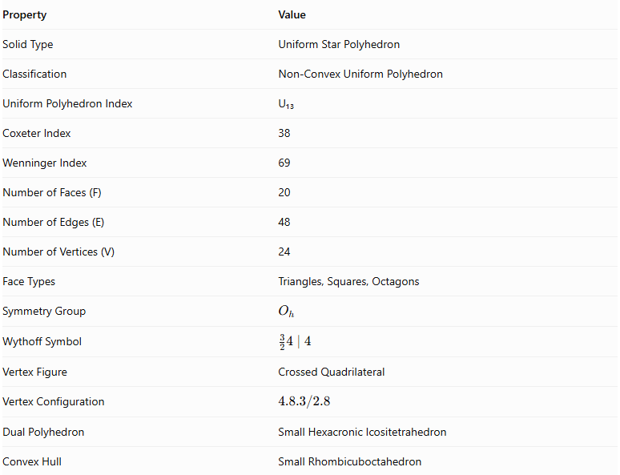
Property | Value
Solid Type | Uniform Star Polyhedron
Classification | Non-Convex Uniform Polyhedron
Uniform Polyhedron Index | U₁₃
Coxeter Index | 38
Wenninger Index | 69
Number of Faces (F) | 20
Number of Edges (E) | 48
Number of Vertices (V) | 24
Face Types | Triangles, Squares, Octagons
Symmetry Group | $$O_{h}$$
Wythoff Symbol | $$\frac{3}{2}4∣4$$
Vertex Figure | Crossed Quadrilateral
Vertex Configuration | $$4.8.3/2.8$$
Dual Polyhedron | Small Hexacronic Icositetrahedron
Convex Hull | Small Rhombicuboctahedron

Face Composition
# Source: AI Source: Provided by: [Data Path: Persons Table -> ID Column: 1, Name_En Column: Motasem Essam] -> From: [ChatGPT] on [7/25/2026]
The Small Cubicuboctahedron has 20 faces distributed among three polygon types.
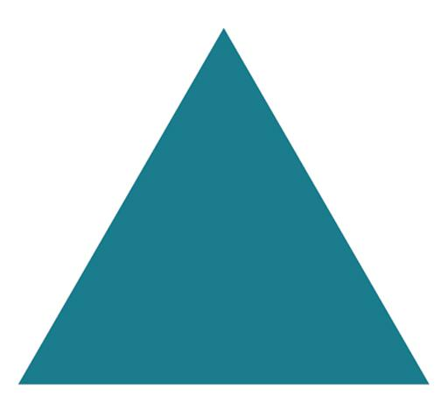
Equilateral Triangles
8
Three equal sides and three 60° angles.
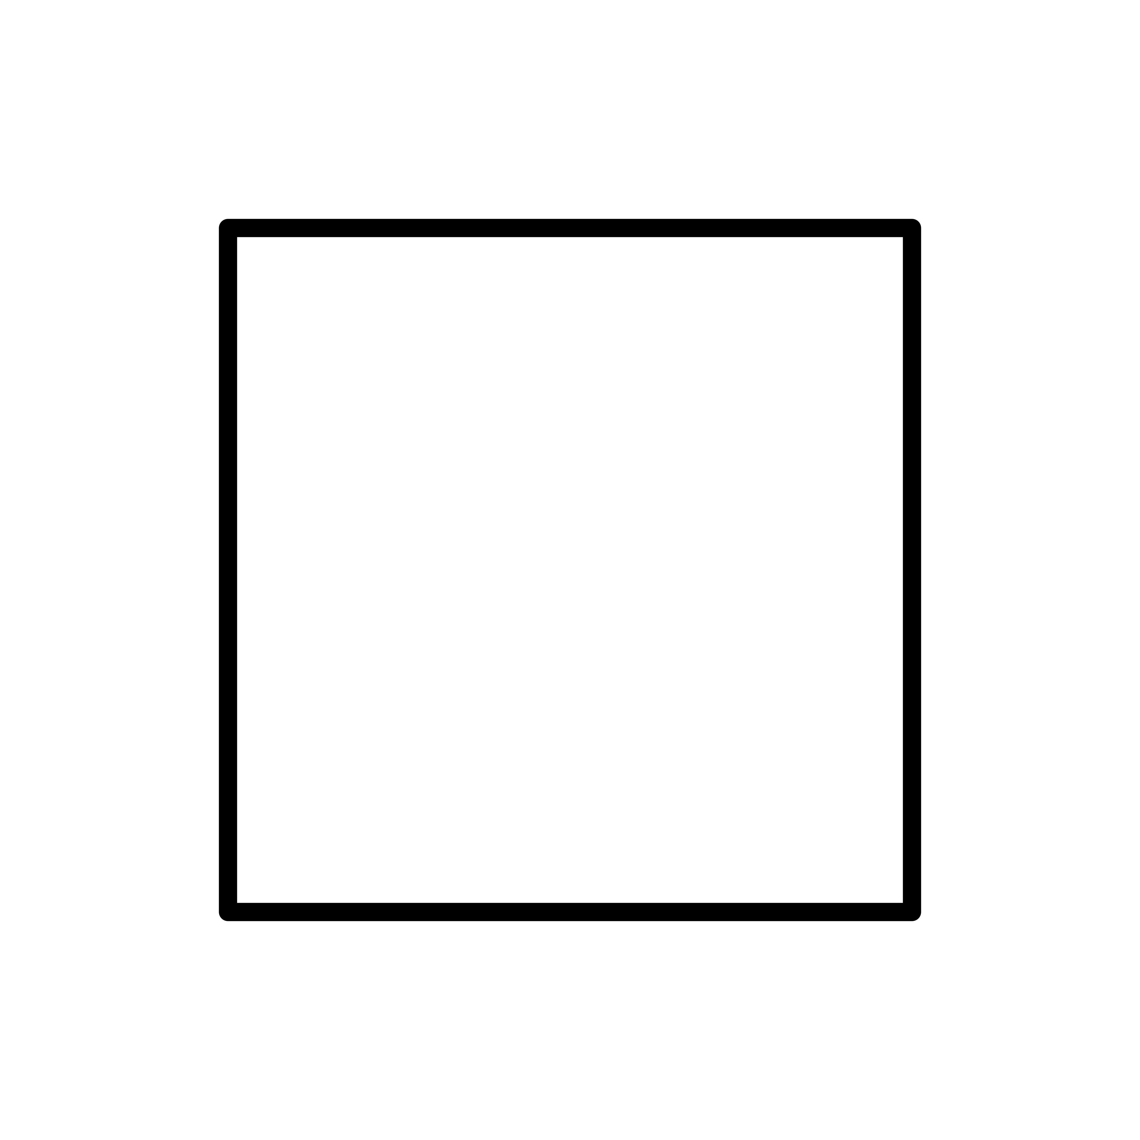
Squares
6
Four equal sides and four 90° angles.
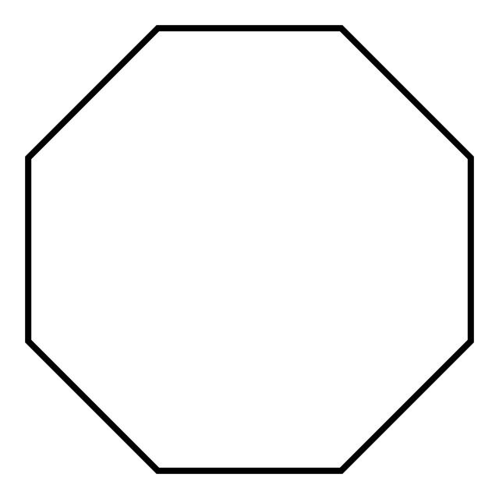
Regular Octagons
6
Eight equal sides and eight 135° angles.
The face composition is represented by:
$$\boxed{8\{3\}+6\{4\}+6\{8\}}$$
Where:
- $\{3\}$ represents an equilateral triangle.
- $\{4\}$ represents a square.
- $\{8\}$ represents a regular octagon.

Vertex Configuration
# Source: AI Source: Provided by: [Data Path: Persons Table -> ID Column: 1, Name_En Column: Motasem Essam] -> From: [ChatGPT] on [7/25/2026]
The Small Cubicuboctahedron has 24 vertices.
Every vertex has the same local arrangement of polygonal faces, and its vertex figure is a crossed quadrilateral.
Its vertex configuration is:
$$\boxed{4.8.\frac{3}{2}.8}$$
This notation describes the arrangement of a square, an octagon, a star-oriented triangular contribution, and another octagon around a vertex.
The crossed arrangement is an important feature distinguishing this solid from convex uniform polyhedra.

Construction
# Source: AI Source: Provided by: [Data Path: Persons Table -> ID Column: 1, Name_En Column: Motasem Essam] -> From: [ChatGPT] on [7/25/2026]
The Small Cubicuboctahedron can be understood as a faceting of the rhombicuboctahedron.
A faceting uses the same vertex set while changing the selection and arrangement of edges and faces.
Its construction can be understood through these stages:
- Begin with the vertex arrangement of a small rhombicuboctahedron.
- Retain the 24 vertex positions.
- Select edges that form 8 equilateral triangular faces.
- Arrange 6 square faces parallel to the corresponding cube-oriented planes.
- Arrange 6 regular octagonal faces in the remaining face positions.
- Allow the resulting faces to intersect according to the uniform star-polyhedron arrangement.
The resulting solid has 20 faces, 48 edges, and 24 vertices.

Geometric Dimensions and Formulas
# Source: AI Source: Provided by: [Data Path: Persons Table -> ID Column: 1, Name_En Column: Motasem Essam] -> From: [ChatGPT] on [7/25/2026]
Let:
- $a$ = common edge length.
- $A_{3}$ = area of one equilateral triangular face.
- $A_{4}$ = area of one square face.
- $A_{8}$ = area of one regular octagonal face.
- $S$ = sum of the individual face areas.
Equilateral triangular face area:
$$A_{3}=\frac{\sqrt{3}}{4}a^{2}$$
Square face area:
$$A_{4}=a^{2}$$
Regular octagonal face area:
$$A_{8}=2(1+\sqrt{2})a^{2}$$
Sum of the individual face areas:
$$S=8A_{3}+6A_{4}+6A_{8}$$
Substituting:
$$S=8(\frac{\sqrt{3}}{4}a^{2})+6a^{2}+12(1+\sqrt{2})a^{2}$$
Therefore:
$$\boxed{S=(18+12\sqrt{2}+2\sqrt{3})a^{2}}$$
This represents the sum of the areas of all 20 faces, counting each face separately. It is not the non-overlapping external boundary area.
Circumradius for unit edge length:
$$\boxed{R=\frac{\sqrt{5+2\sqrt{2}}}{2}}$$
For a general edge length $a$:
$$\boxed{R=\frac{a}{2}\sqrt{5+2\sqrt{2}}}$$

Euler Characteristic
# Source: AI Source: Provided by: [Data Path: Persons Table -> ID Column: 1, Name_En Column: Motasem Essam] -> From: [ChatGPT] on [7/25/2026]
Using the conventional counts of vertices, edges, and faces:
$$χ=V-E+F$$
Substituting:
$$χ=24-48+20$$
$$\boxed{χ=-4}$$
Unlike a convex polyhedron, the Small Cubicuboctahedron does not have Euler characteristic 2.
When interpreted as a connected, orientable abstract surface, its Euler characteristic corresponds to genus 3:
$$χ=2-2g$$
$$-4=2-2g$$
$$\boxed{g=3}$$
This is a topological interpretation of its face-edge-vertex structure, rather than a description of its ordinary convex interior.

Symmetry
# Source: AI Source: Provided by: [Data Path: Persons Table -> ID Column: 1, Name_En Column: Motasem Essam] -> From: [ChatGPT] on [7/25/2026]
The Small Cubicuboctahedron has full octahedral symmetry.
Its symmetry group is:
$$\boxed{O_{h}}$$
It possesses:
- Rotational symmetries associated with the cube and octahedron.
- Reflection symmetries.
- Inversion symmetry.
- Equivalent vertices under its symmetry transformations.
The high symmetry explains why every vertex has the same local geometric arrangement, despite the intersections between faces.

Constructing a Small Cubicuboctahedron

Geometric Instruments
# Source: AI Source: Provided by: [Data Path: Persons Table -> ID Column: 1, Name_En Column: Motasem Essam] -> From: [ChatGPT] on [7/25/2026]
The following instruments can be used to construct a physical geometric model:
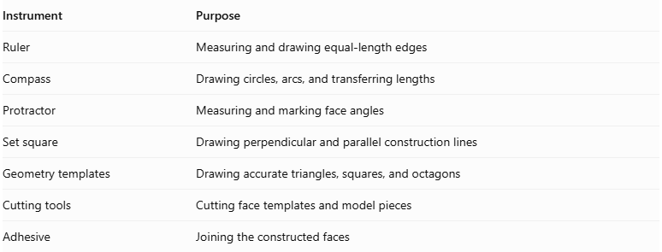
Instrument | Purpose
Ruler | Measuring and drawing equal-length edges
Compass | Drawing circles, arcs, and transferring lengths
Protractor | Measuring and marking face angles
Set square | Drawing perpendicular and parallel construction lines
Geometry templates | Drawing accurate triangles, squares, and octagons
Cutting tools | Cutting face templates and model pieces
Adhesive | Joining the constructed faces

Instrument-Based Construction Procedures

Method 1: Constructing from a Rhombicuboctahedral Framework
# Source: AI Source: Provided by: [Data Path: Persons Table -> ID Column: 1, Name_En Column: Motasem Essam] -> From: [ChatGPT] on [7/25/2026]
The Small Cubicuboctahedron is related to the Rhombicuboctahedron through a faceting arrangement. This provides a useful geometric starting point for a physical construction.
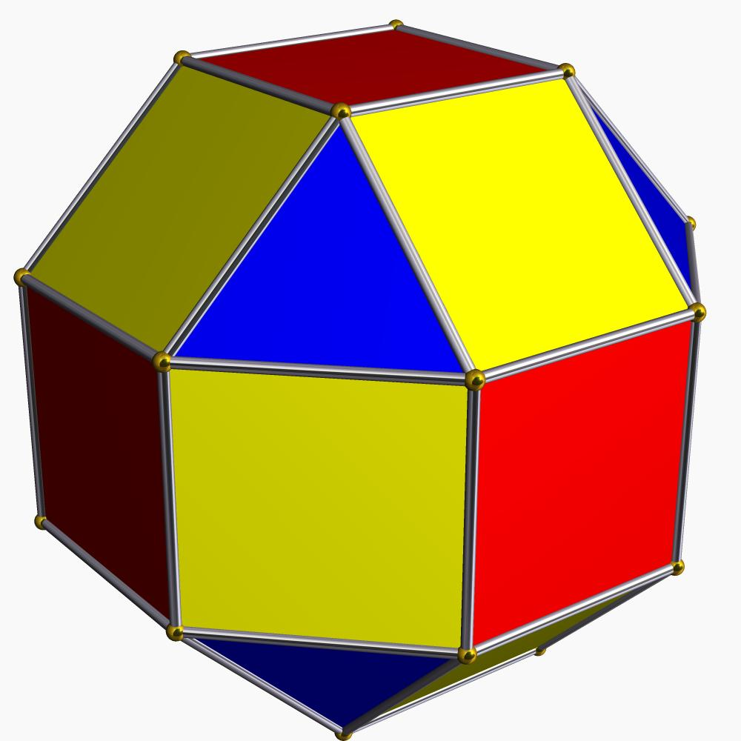
Steps:
- Construct or obtain a regular rhombicuboctahedral framework with equal edge lengths.
- Identify its 24 vertices and 48 edges.
- Mark the face regions required for the Small Cubicuboctahedron.
- Arrange the triangular, square, and octagonal face regions according to the target solid's symmetry.
- Reposition the face planes to produce the required non-convex faceting.
- Verify that the resulting structure contains 8 triangles, 6 squares, and 6 octagons.
- Check that all edges have equal lengths and that all vertices have equivalent local arrangements.

Method 2: Constructing Individual Polygonal Faces
# Source: AI Source: Provided by: [Data Path: Persons Table -> ID Column: 1, Name_En Column: Motasem Essam] -> From: [ChatGPT] on [7/25/2026]
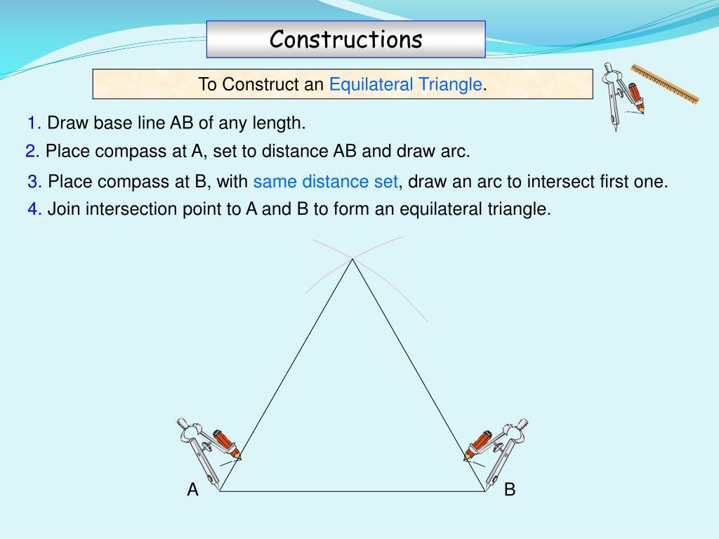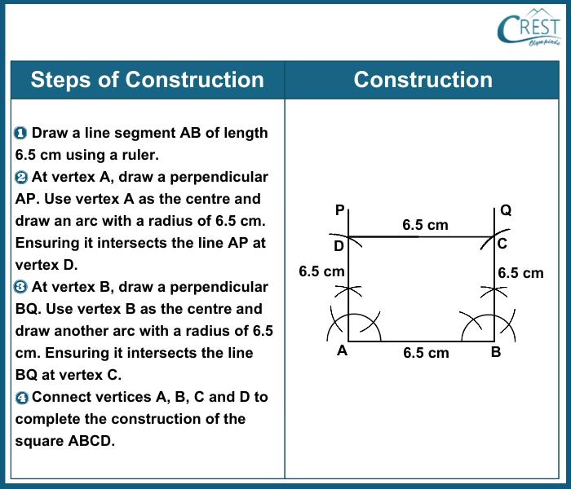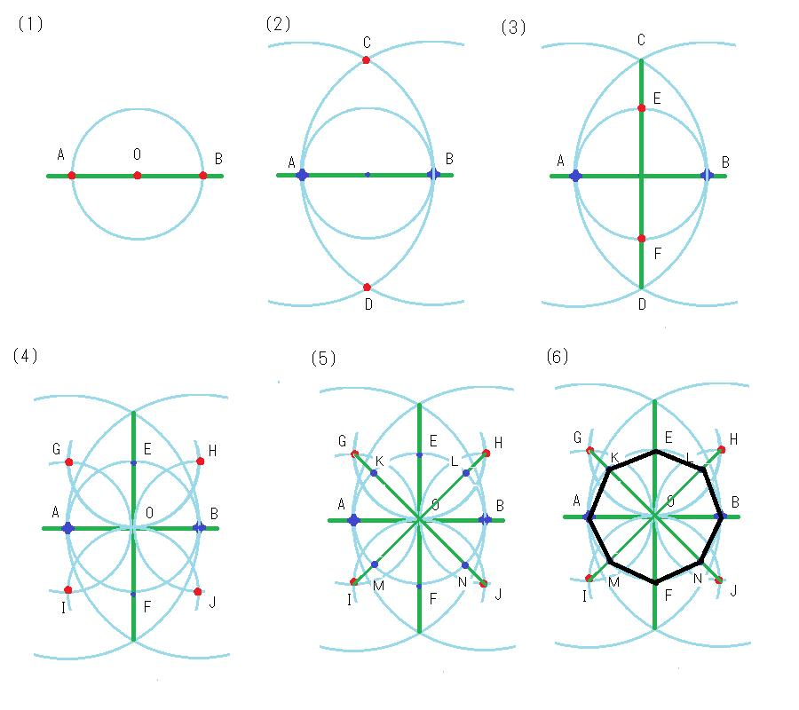
Steps:
- Draw eight equilateral triangles using a compass and ruler.
- Draw six squares with the same side length.
- Draw six regular octagons with the same side length.
- Label the edges of all faces to identify matching connections.
- Arrange the faces according to the Small Cubicuboctahedron's symmetry.
- Join the faces into a three-dimensional model.
- Adjust the connections to reproduce the crossed and non-convex geometry.
Important: Simply joining the 20 polygonal faces arbitrarily will not produce the correct solid. Their orientations and edge connections must follow the uniform polyhedron's structure.

Relationship to Other Geometric Solids
# Source: AI Source: Provided by: [Data Path: Persons Table -> ID Column: 1, Name_En Column: Motasem Essam] -> From: [ChatGPT] on [7/25/2026]
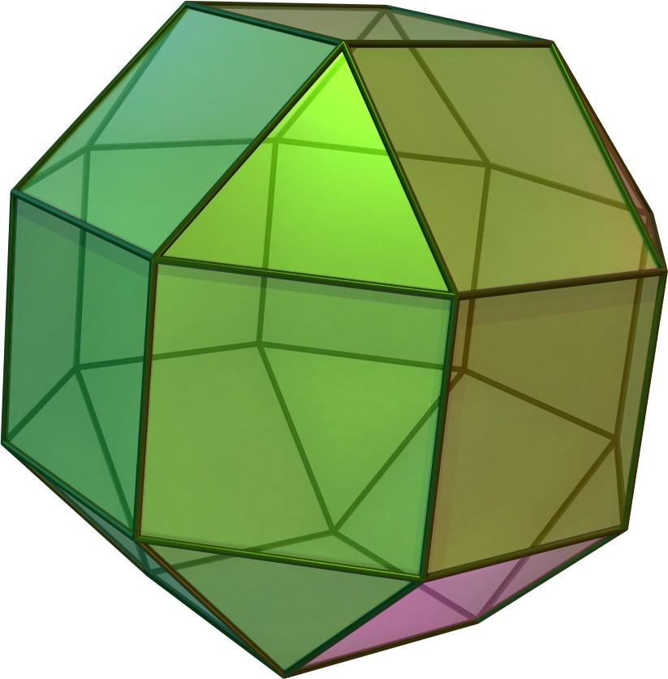
Small Rhombicuboctahedron
The convex hull of the Small Cubicuboctahedron. Both share the same 24 vertex positions.
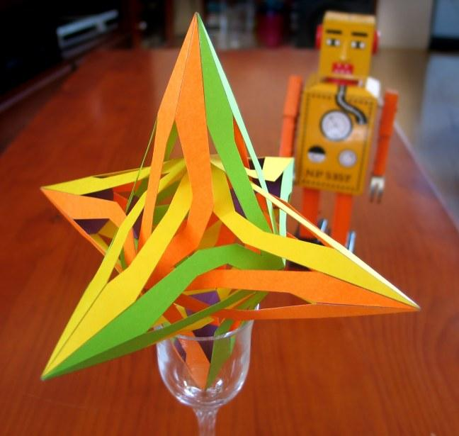
Small Hexacronic Icositetrahedron
The dual polyhedron of the Small Cubicuboctahedron. It has 24 dart-shaped faces.
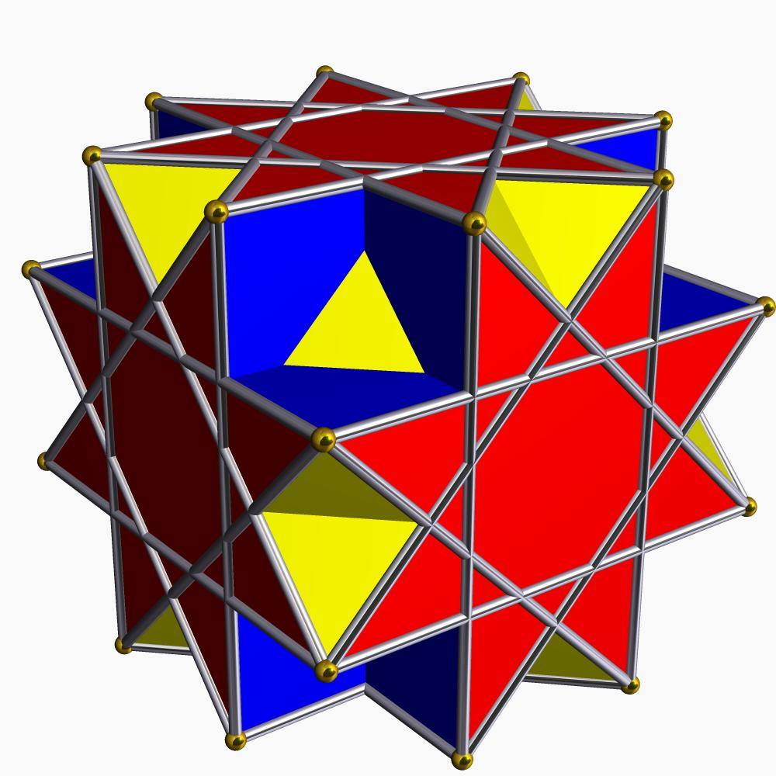
Great Cubicuboctahedron
Another uniform star polyhedron with 8 triangular faces, 6 square faces, and 6 star-octagonal faces.
Rhombicuboctahedron
A convex Archimedean solid with 8 triangular faces and 18 square faces. It provides the vertex arrangement used by the Small Cubicuboctahedron.

Comparison with Related Uniform Polyhedra
# Source: AI Source: Provided by: [Data Path: Persons Table -> ID Column: 1, Name_En Column: Motasem Essam] -> From: [ChatGPT] on [7/25/2026]
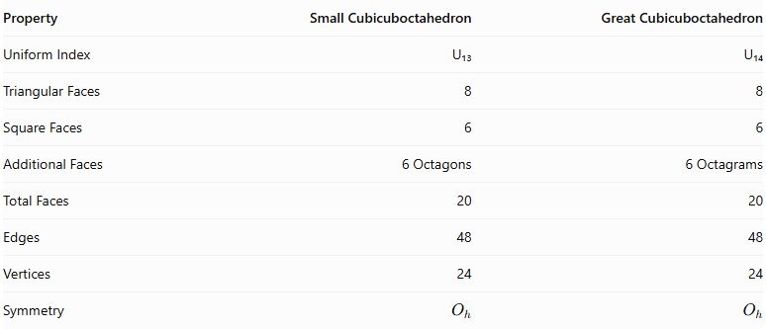
Property | Small Cubicuboctahedron | Great Cubicuboctahedron
Uniform Index | U₁₃ | U₁₄
Triangular Faces | 8 | 8
Square Faces | 6 | 6
Additional Faces | 6 Octagons | 6 Octagrams
Total Faces | 20 | 20
Edges | 48 | 48
Vertices | 24 | 24
Symmetry | $$O_{h}$$ | $$O_{h}$$
The main difference is the shape of the six additional faces: regular octagons in the Small Cubicuboctahedron and regular octagrams in the Great Cubicuboctahedron.

Main Classification
# Source: AI Source: Provided by: [Data Path: Persons Table -> ID Column: 1, Name_En Column: Motasem Essam] -> From: [ChatGPT] on [7/25/2026]
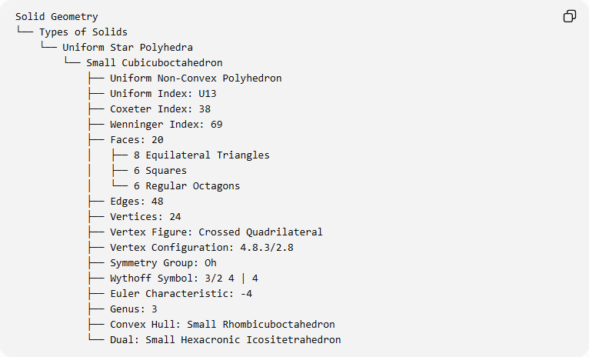
Solid Geometry
└── Types of Solids
└── Uniform Star Polyhedra
└── Small Cubicuboctahedron
├── Uniform Non-Convex Polyhedron
├── Uniform Index: U13
├── Coxeter Index: 38
├── Wenninger Index: 69
├── Faces: 20
│ ├── 8 Equilateral Triangles
│ ├── 6 Squares
│ └── 6 Regular Octagons
├── Edges: 48
├── Vertices: 24
├── Vertex Figure: Crossed Quadrilateral
├── Vertex Configuration: 4.8.3/2.8
├── Symmetry Group: Oh
├── Wythoff Symbol: 3/2 4 | 4
├── Euler Characteristic: -4
├── Genus: 3
├── Convex Hull: Small Rhombicuboctahedron
└── Dual: Small Hexacronic Icositetrahedron

Key Points
# Source: AI Source: Provided by: [Data Path: Persons Table -> ID Column: 1, Name_En Column: Motasem Essam] -> From: [ChatGPT] on [7/25/2026]
- The Small Cubicuboctahedron is a uniform star polyhedron.
- It is classified as U₁₃.
- It contains 20 faces: 8 triangles, 6 squares, and 6 octagons.
- It has 48 edges and 24 vertices.
- All its edges have equal lengths.
- Every vertex has the same crossed quadrilateral vertex figure.
- Its symmetry group is $O_{h}$.
- It is a faceting of the rhombicuboctahedron.
- Its convex hull is the small rhombicuboctahedron.
- Its dual is the small hexacronic icositetrahedron.

Conclusion
# Source: AI Source: Provided by: [Data Path: Persons Table -> ID Column: 1, Name_En Column: Motasem Essam] -> From: [ChatGPT] on [7/25/2026]
The Small Cubicuboctahedron is an important example of a uniform star polyhedron. Its combination of triangular, square, and octagonal faces creates a highly symmetrical non-convex structure with intersecting faces. Its relationship to the rhombicuboctahedron, its crossed quadrilateral vertex figure, and its dual polyhedron make it a distinctive member of the uniform star polyhedra family.

